Solve a sin x + b cos x = c
Yue Kwok Choy
Question
Solve : 12 sin x + 5 cos x = 4
α
12
5
13
O
Q
P

Method 1
Construct a triangle OPQ with 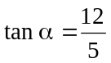 .
∴ α ≈ 67.380º .
Also, 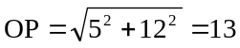
Now, 12 sin x + 5 cos x = 4
(13 sin α) sin x + (13 cos α) cos x = 4
13 (cos x cos α + sin x sin α) = 4
13 cos (x – α) = 4
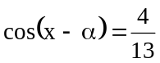
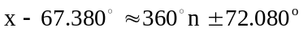
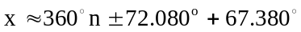
∴ ,where n is an integer . …. (1)

Method 2
β
5
12
13
O
Q
P
Construct a triangle OPQ with 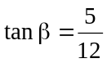 .
∴ α ≈ 22.620º .
Also,
Now, 12 sin x + 5 cos x = 4
(13 cos β) sin x + (13 sin β) cos x = 4
13 (sin x cos β + cos x sin β) = 4
13 sin ( x + β) = 4
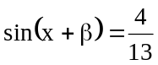
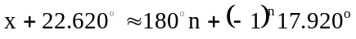
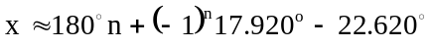 , where n is an integer . …. (2)

To show that the solution set (2) is the same as the solution set (1), we need to divide the solution into odd and even cases :
(a) n = 2m ,
(b) n = 2m + 1, , where m is an integer.
Method 3 (t – method)
Let 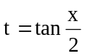 .
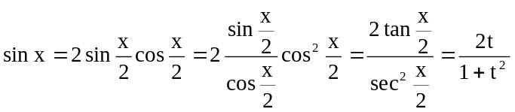
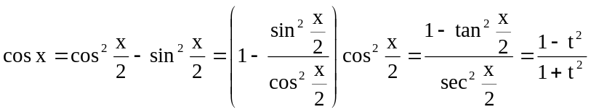
Now, the equation : 12 sin x + 5 cos x = 4
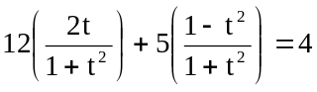
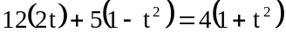
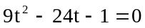
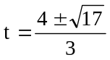
∴ 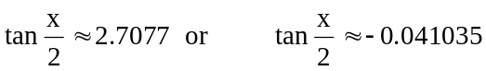
∴ 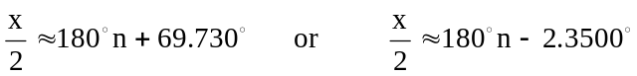
∴ , where n is an integer . …. (3)

Method 4 (unsatisfactory)

12 sin x + 5 cos x = 4
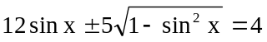
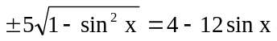
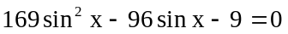
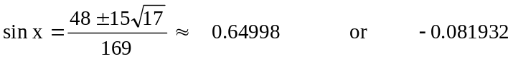
…. (4)

Method 4 is unsatisfactory since solution set (4) gives a larger solution set than (1), (2) or (3).
Readers please explain. What solutions should be rejected ? How to reject ?

Explanation

Squaring equation creates roots! That is why Method 4 is not recommended.

Finding the redundant roots is tedious:

In (4),
(a) When 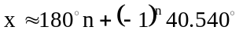.
(i) n = 2m, 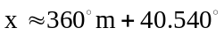
(ii) n = 2m + 1, 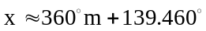
(b) When 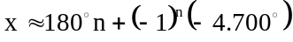
(i) n = 2m, 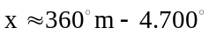
(ii) n = 2m + 1, 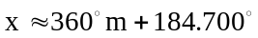

Therefore (4) is equivalent to :
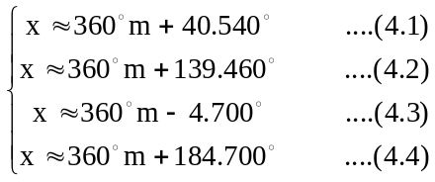

(4.2) and (4.3) are good solutions.
(4.1) and (4.4) should be rejected.

For (4.1), 12 sin x + 5 cos x
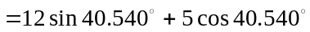
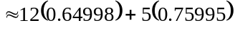
≈ 11.59951
≠ 4
∴ 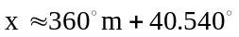 does not satisfy the equation 12 sin x + 5 cos x = 4, and should be rejected.

Similarly, for (4.4), 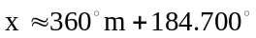 should be rejected.

